**CHAPTER 5: SCHEDULE**

**5.1 Work Breakdown Structure:-**

**Density Based Traffic Controller**

**Requirement**

**Specification**

**Requirement**

**Analysis**

**Project**

**Development**

**Requirement**

**Gathering**

**System Testing**

**Unit Testing**

**Implementation of modules**

**Documentation**

**Implementation**

**Testing**

**Design**

**Block Diagram and Procedural Design**

**Integration Testing**

**5.2 Task Network Representation:-**

**Monish Vadhwani**

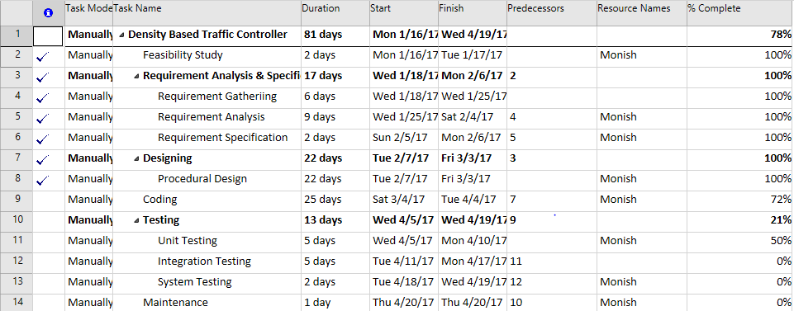

**Umang Kanage**

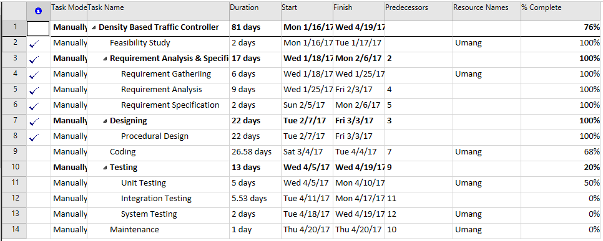

**Yash Sonar**

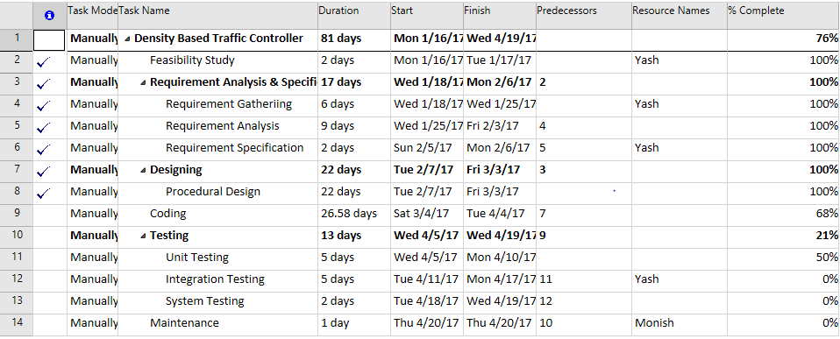

**5.3 Gantt Chart:-**

**Monish Vadhwani**

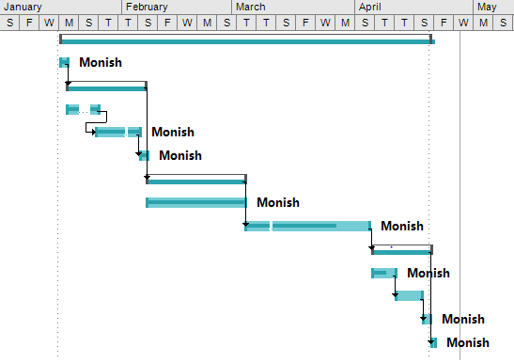

**Umang Kanage**

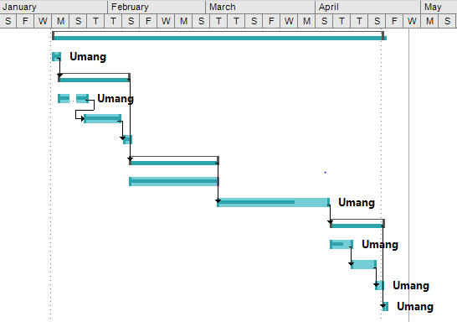

**Yash Sonar**

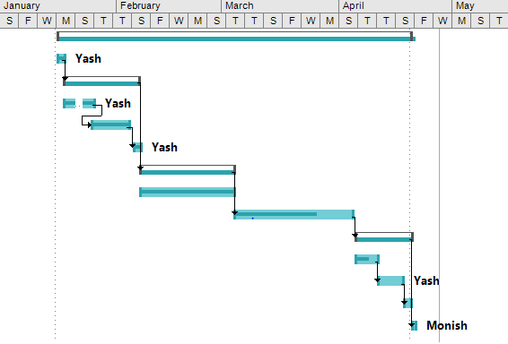

**5.4 PERT Chart:-**

**Monish Vadhwani**

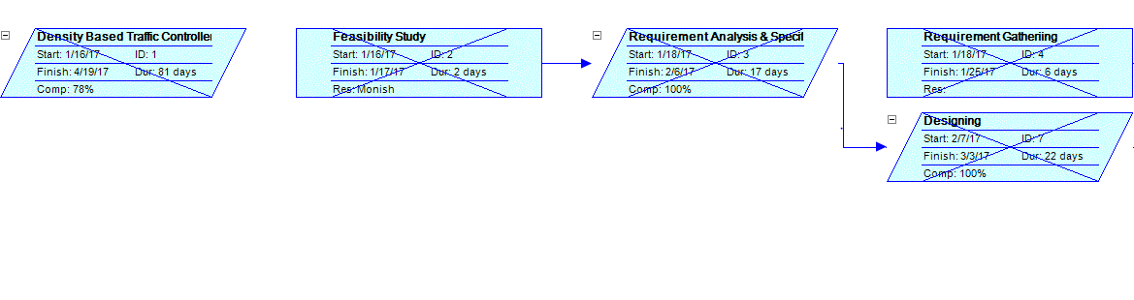

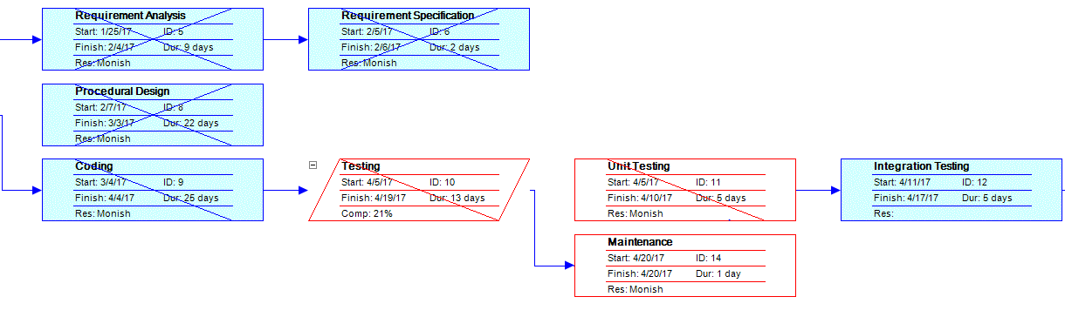

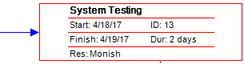

**Umange Kanage**

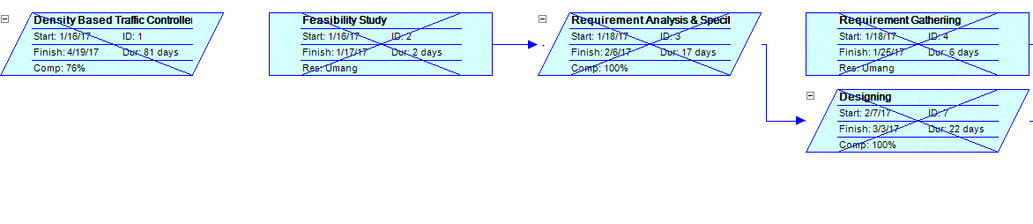

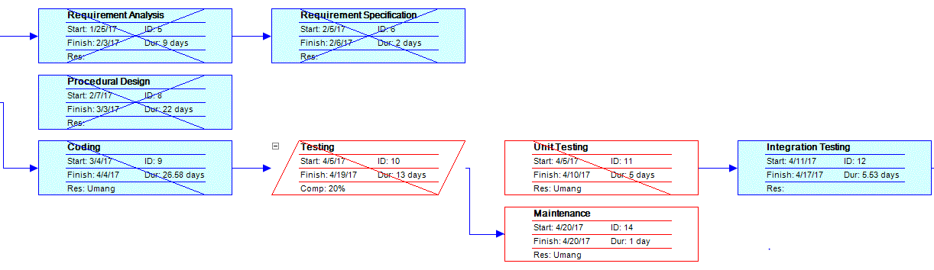

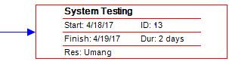

**Yash Sonar**

